Social status, foraging behavior, and space allocation among
group-forming coral-reef fish

Social groups in the animal kingdom are often hierarchical, where dominant individuals experience improved access to a larger share of resources and mating opportunities. As food for planktivorous fish is carried by currents, individual position within the current often dictates food availability. Indeed, in some cases in the animal kingdom, the position within the group is associated with social status and resources availability.
Dascyllus marginatus, a common coral-dwelling damselfish in the Red-Sea, forms social groups of up to 25 individuals. The groups are territorial and long-lived (months, years), consisting of dominant males and subordinate females. The fish seek shelter between the branches of the hosting coral. During the day the fish feed on drifting zooplankton near and up-current of their sheltering coral. Thereby, individuals that are found farther away (more up-current) encounter more prey. The occurrence of a vertical gradient of increasing zooplankton density with height above the reef, means, in addition, that foraging at higher heights above sea floor should augment feeding rates. On the other hand, positions further up-current and higher above the coral imply greater distance from shelter, forming a trade-off between feeding success and risk of predation.
The goal of my research is to test whether exists a relationship between the individual’s social status and its foraging position and behavior, in their natural environment. Assuming that high-ranking individuals have “first choice” of foraging position, their position around the coral may possibly reflect the optimal position in the trade-off between predation risk and foraging in this species.
For this test, I have collected video data of two groups of individually marked fish, in their natural environment. Data was collected using an underwater 3D video system I developed. The system allows the identification of individuals within the group and the tracking of their motions in situ. It is based on three synchronized cameras, situated around the fish home coral, capturing the fish position at every given moment from at least two different points of view, allowing 3D reconstruction using DLT (direct linear transformation) method. Visible aggressive interactions among the fish were used as indicators of the social status of each fish, which were used to examine relationships between hierarchical status and foraging position, if occurring.
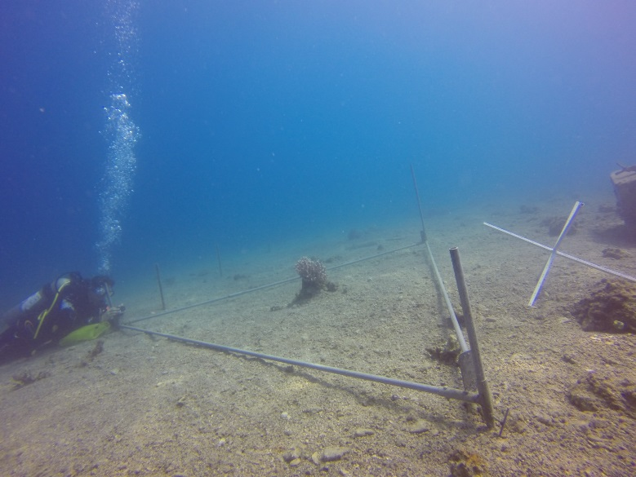
Figure 1: Experimental set-up. Three high-resolution cameras filming at 30 fps, situated on each corner of equilateral triangle frame. The frame is placed around the fish home coral in the coral reef.

Preliminary findings suggests that there is a strict and constant linear hierarchy within the group of D.marginatus, and that each fish maintains a constant foraging position relative to the current and the home coral. Looking at each fish position in different currents (see figure 2), NE or SW, shows that the fish positions are constant and quite discrete. The alpha (blue) remains at the front of the coral and slightly obstructs the delta (magenta) foraging territory. The beta (red) stays slightly above the rest of the fish, where presumably there is higher plankton density. With current shift, we can see that fish positions relative to the coral remain the same, excluding the alpha. The alpha moves to the front of the coral, and will always be the first to meet the current. Many exciting findings are still pending processing and analysis. Preliminary processing of data from the second group suggest hierarchal position patterns similar to those of the first group.
My study uses a unique (nevertheless common) form of grouping – that of site attached coral reef fishes - in order to experimentally elucidate the ecological impact of social status among grouping fish under natural conditions. Behavioral and hierarchical mechanisms in fish are relatively difficult to investigate; my research offers a novel approach to understand these complex social processes.

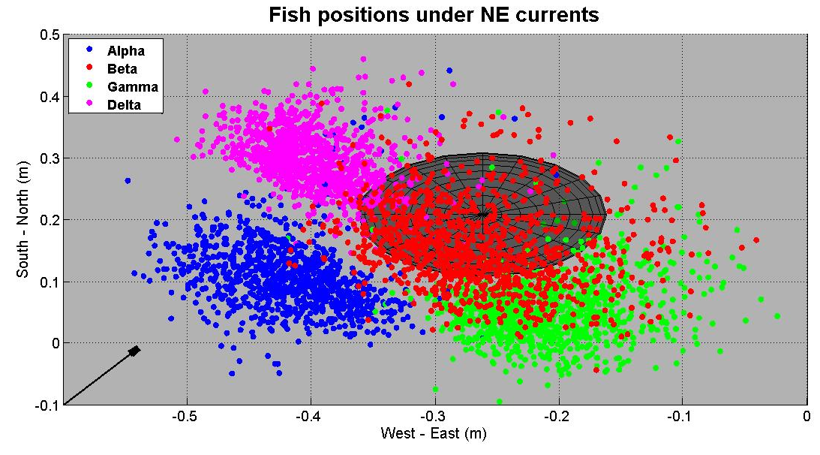
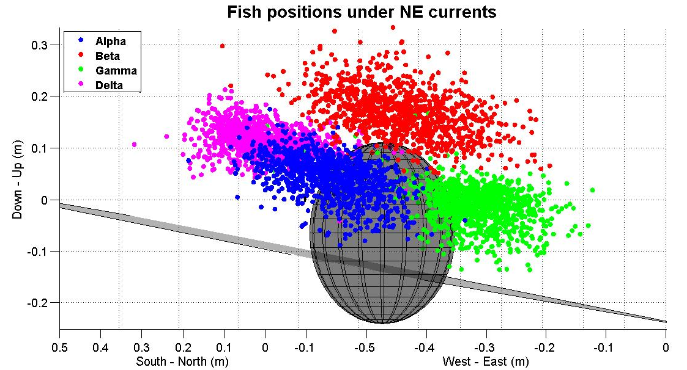
Figure 2: Fish positions under Northeast (a and b) and Southwest (c and d) currents around their home coral (grey sphere). Each color represents a different fish in the group, marked by hierarchy (see legend). Each point represents a specific fish position. Positions were measured every five seconds during an hour-long videos. In each graph points represent data that was collected in two different days. (a and c) A view from above. Black arrow represents current direction. (b and d) A view from current direction. Grey line represents the sea floor (the coral is on a slope).

b
a

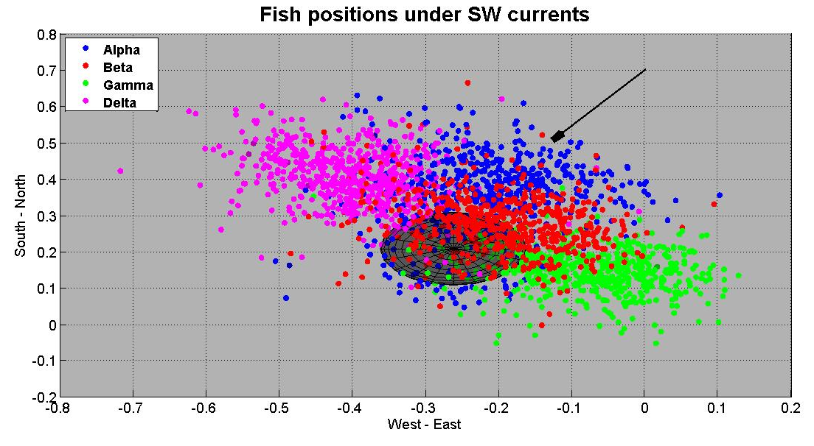
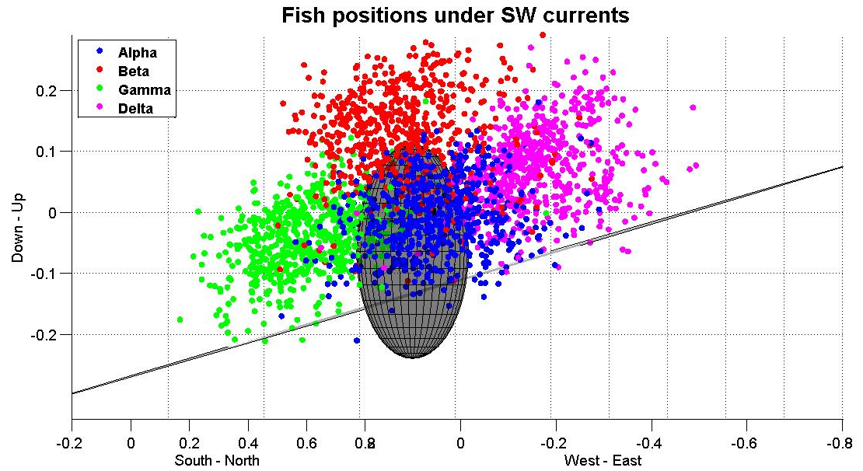
c
d

